CSS - cascading style sheet

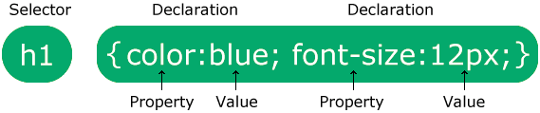

div.container>div.box*3

Text :

text-align: center;

class="center large" => text centerla larga irukkum.

Margin => namaba kudukkura content marginal start aaganuma choose panrathu (margin-left:20px )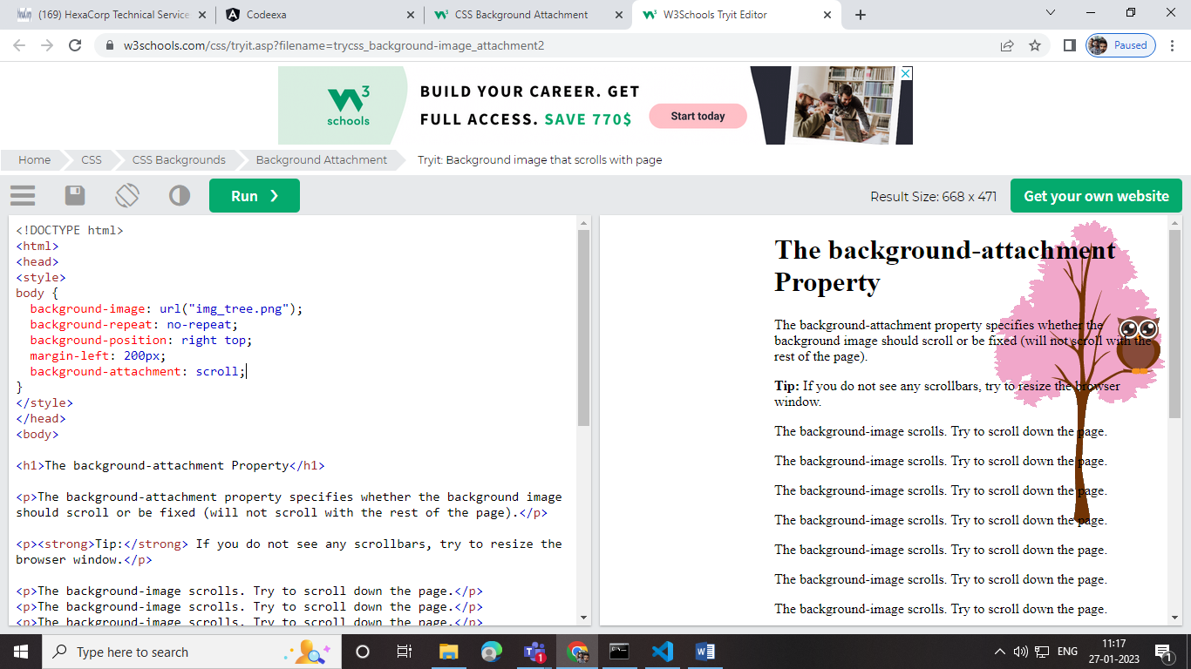

Margin-right:20px

Margin rightlarunthu 200 px capp vittu irukkum

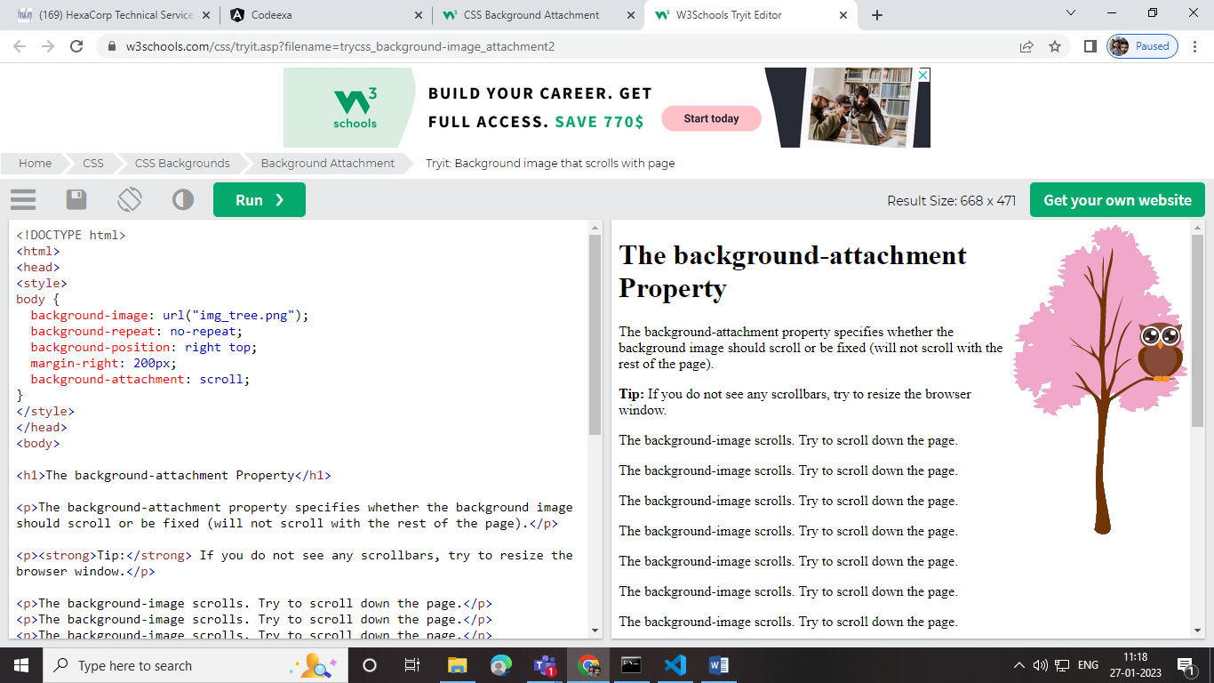

Colors :

Rgb=> red , green, blue

Background:

I n these chapters, you will learn about the following CSS background properties:

* background->color.obasity it will reduce the bg color
* background-image->
* background-repeat
* background-attachment
* background-position
* background (shorthand property)

bg- image => repeat ;

no-repeat

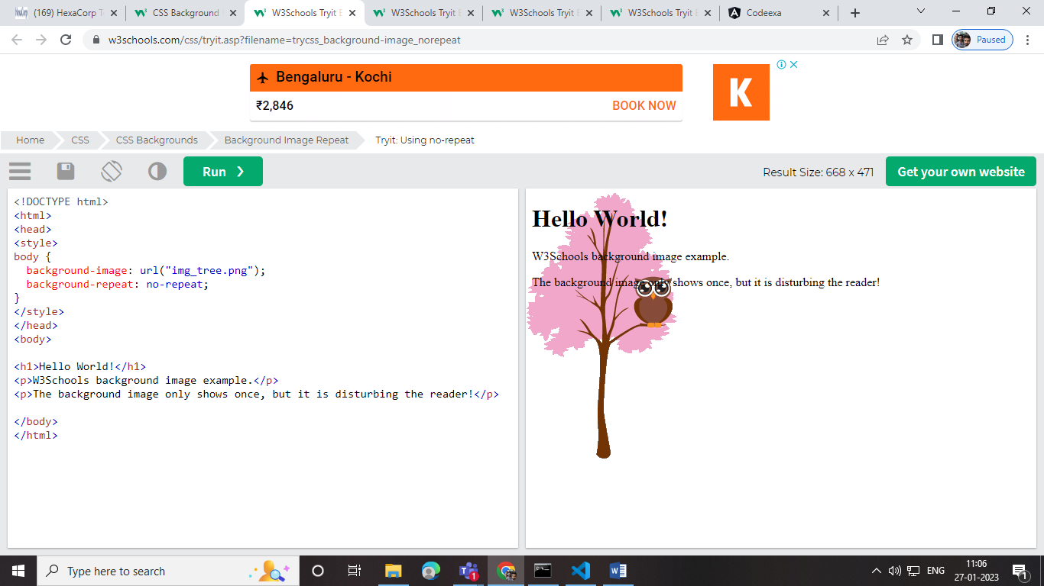

Re-peat y

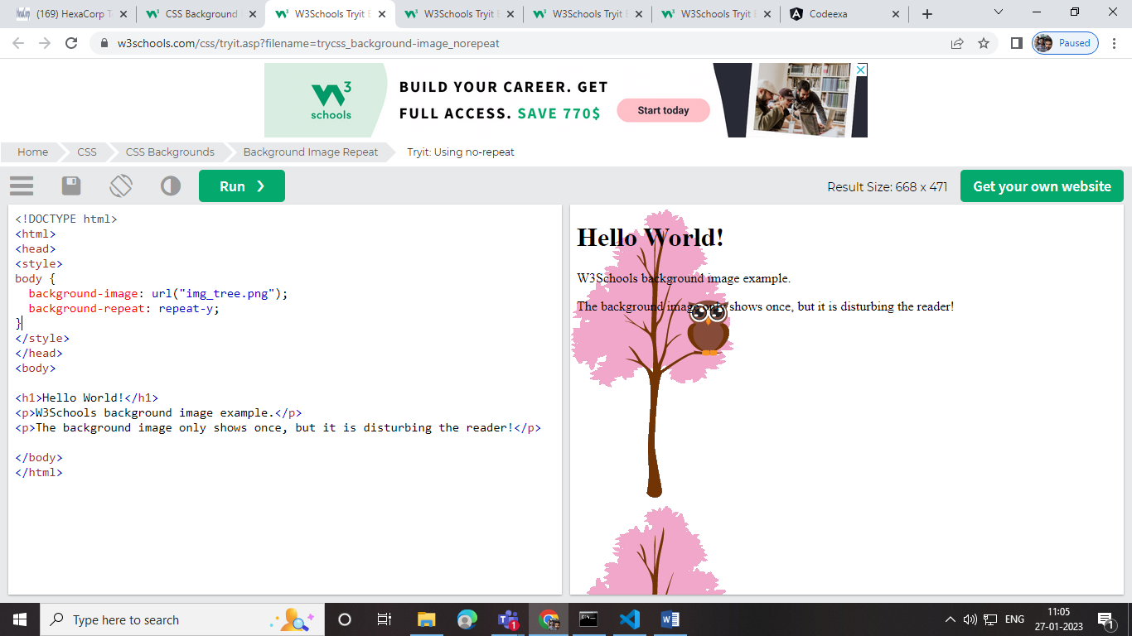

Re-peat x

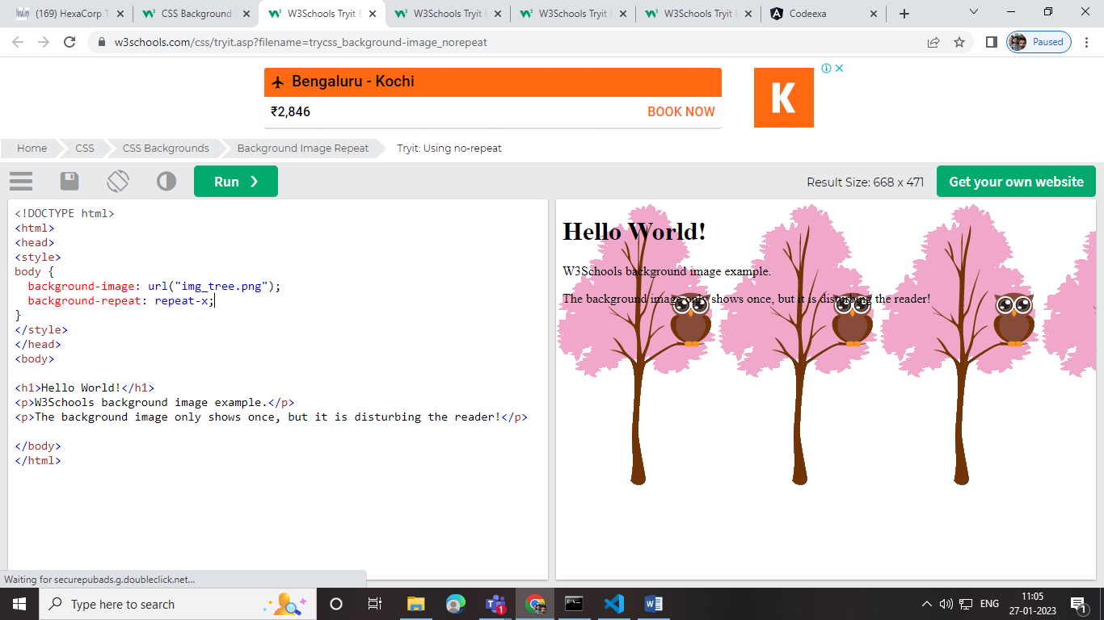

Background-attachment

*Ithu namba set panna bg image DISPLAYALA FIXED POSITIONLA VACHIRUKUM NAMBA SCREEN SCROLL PANNALUM SCREENLA IRUKKA CONTENVENA SCROLL AAGUM BUT NAMBA SET PANA BG MATTU FIXED A IRUKKUM*

background-attachment: fixed;

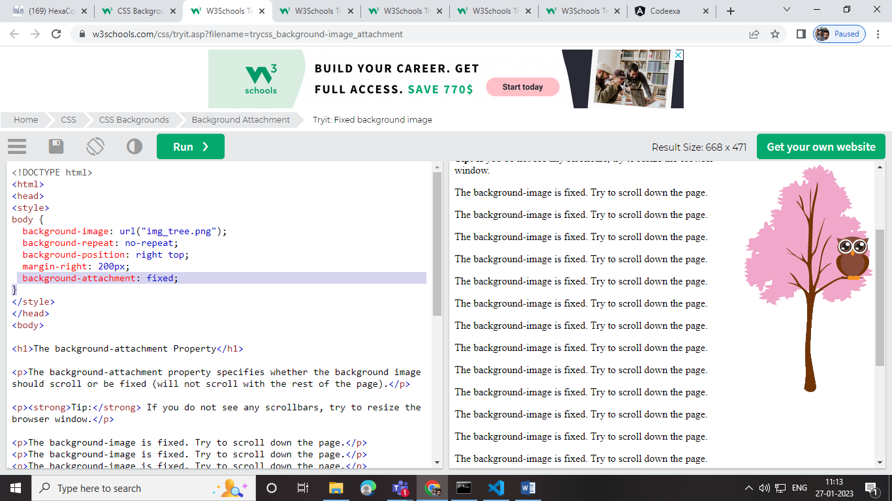like this

Border:

* dotted - Defines a dotted border
* dashed - Defines a dashed border
* solid - Defines a solid border
* double - Defines a double border
* groove - Defines a 3D grooved border. The effect depends on the border-color value
* ridge - Defines a 3D ridged border. The effect depends on the border-color value
* inset - Defines a 3D inset border. The effect depends on the border-color value
* outset - Defines a 3D outset border. The effect depends on the border-color value
* none - Defines no border
* hidden - Defines a hidden border
* border-width: 2px;
* border-color: red;
* border-radius: 5px;
* border: 2px solid red;
* **Content** - The content of the box, where text and images appear
* **Padding** - Clears an area around the content. The padding is transparent
* **Border** - A border that goes around the padding and content
* **Margin** - Clears an area outside the border. The margin is transparent

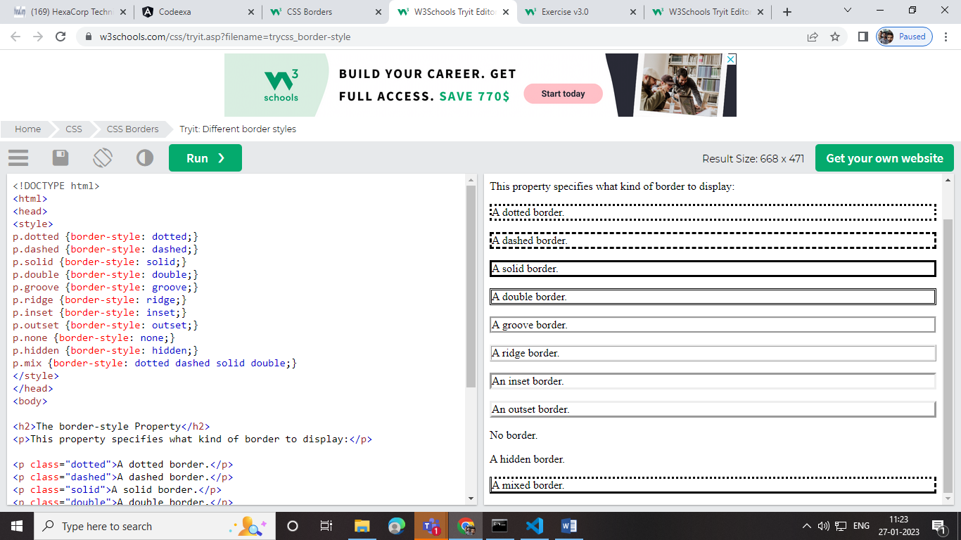

Border sides design

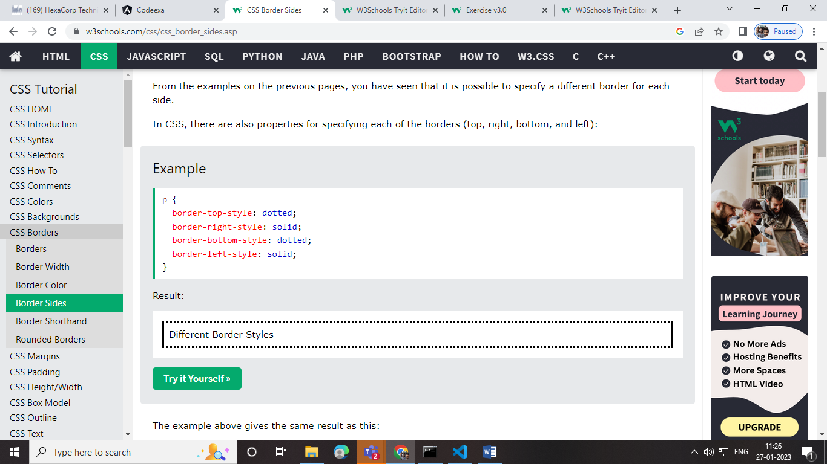

Padding;

Padding is used to create space around an element's content, inside of any defined borders.

* padding-top
* padding-right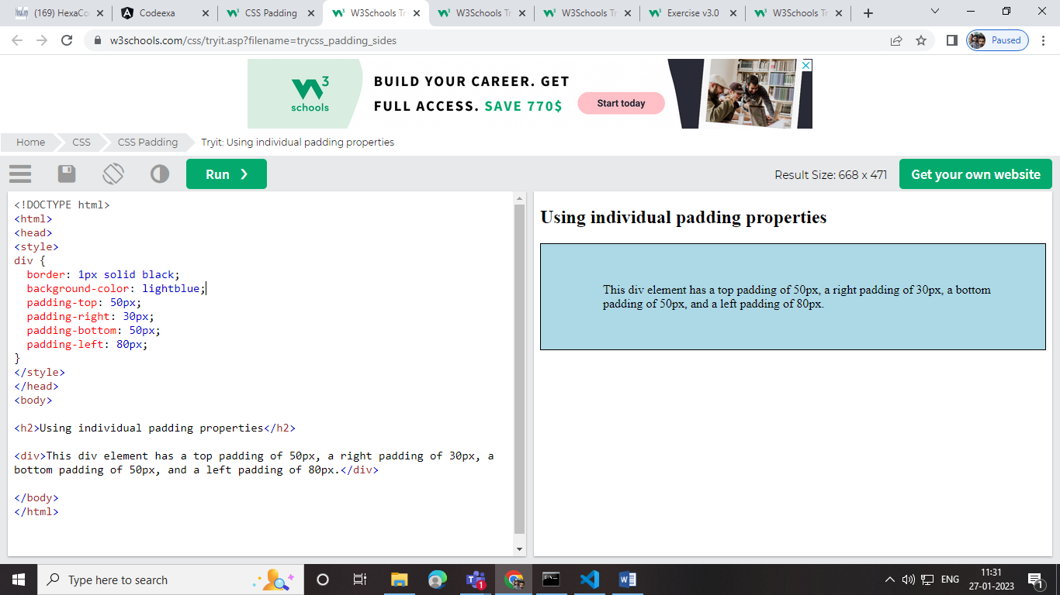
* padding-bottom
* padding-left

If the padding property has three values:

* **padding: 25px 50px 75px;**
  + top padding is 25px
  + right and left paddings are 50px
  + bottom padding is 75px

Height &width;

* auto - This is default. The browser calculates the height and width
* length - Defines the height/width in px, cm, etc.
* % - Defines the height/width in percent of the containing block
* initial - Sets the height/width to its default value
* inherit - The height/width will be inherited from its parent va

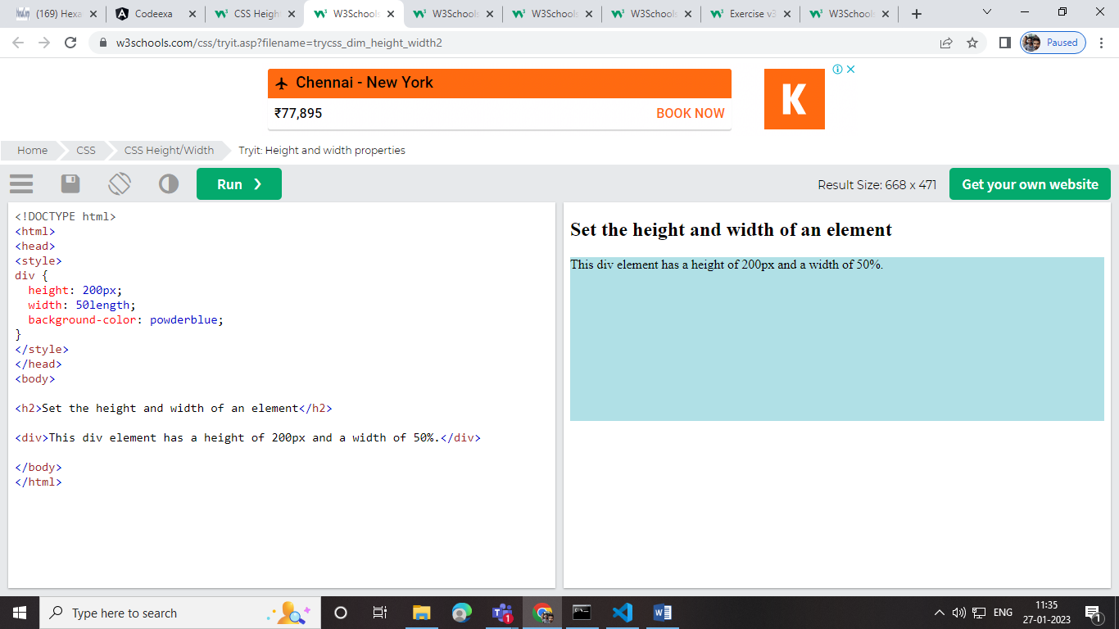

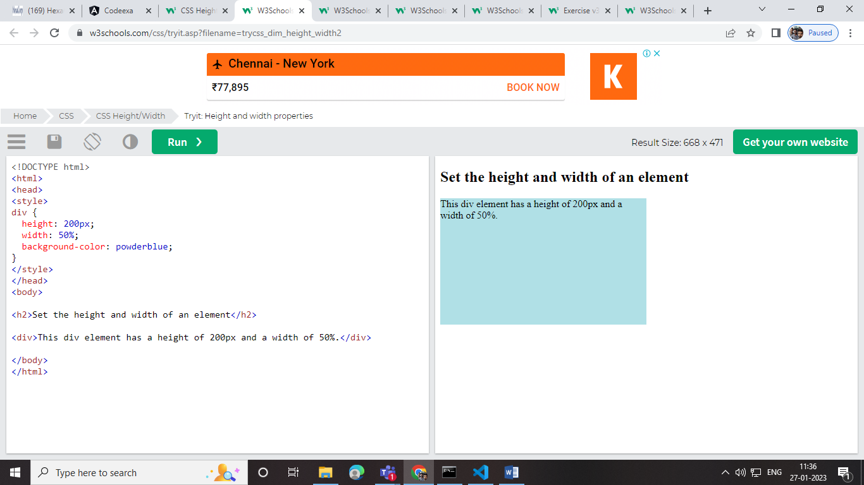

Outline;

Outline same for border .

TEXT DECORATION;

text-decoration: overline;

text-decoration: line-through;

text-decoration: underline;

text-decoration: overline underline;

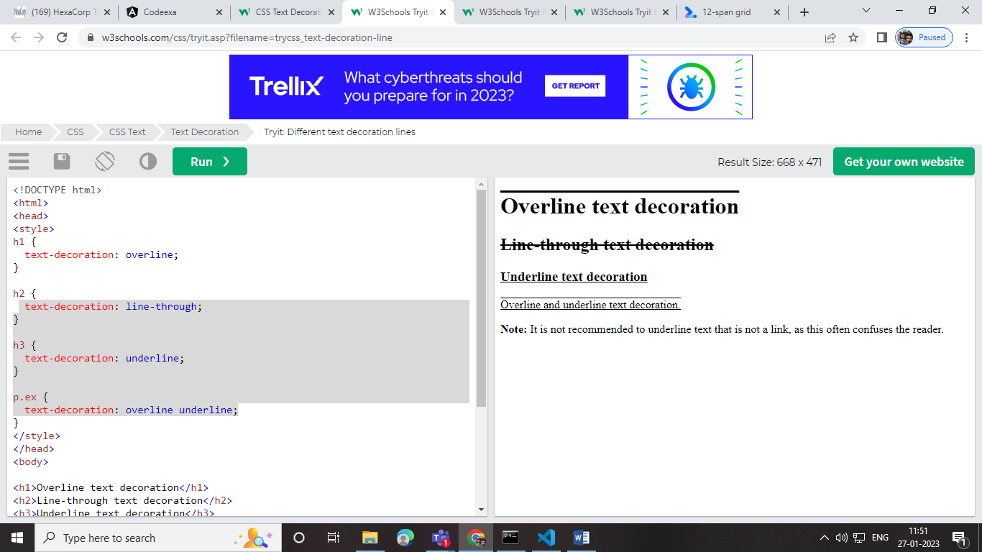

text-indent:70px;

TEXT INDENTNA text start aagura place choose pannikklam

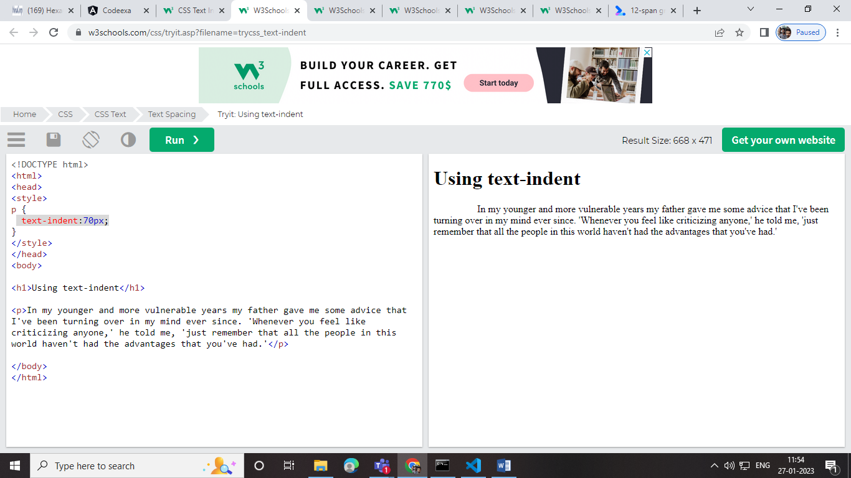

letter-spacing: 5px; between the letters space like s o p I

# text-shadow: 2px 2px;

# list :

# 

# Responsive:

# Add a container element (like <div>) with overflow-x:auto around the <table> element to make it responsive:

Display:

The display property specifies if/how an element is displayed.

Every HTML element has a default display value depending on what type of element it is. The default display value for most elements is block or inline.

Click to show panel

This panel contains a <div> element, which is hidden by default (display: none).

It is styled with CSS, and we use JavaScript to show it (change it to (display: block).

Using max-width instead, in this situation, will improve the browser's handling of small windows. This is important when making a site usable on small devices:

Max-width -> vanthu namba browserku eatha maari adjust pannikklam screen chinnathu pannalum big vachalum.

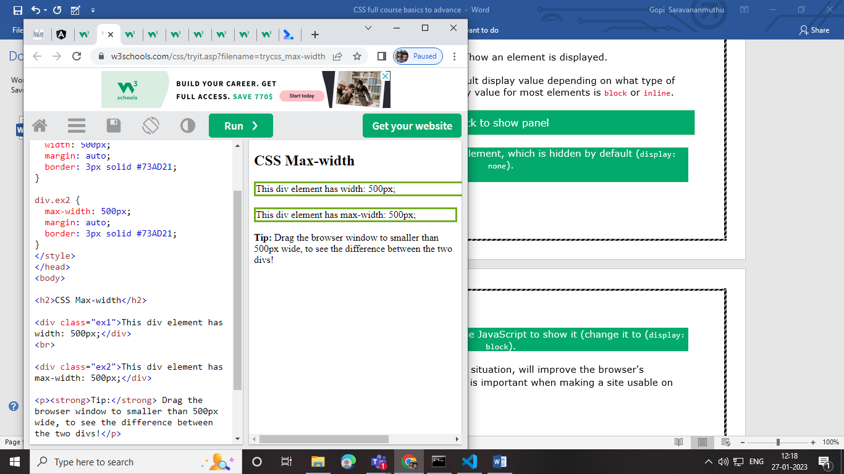

Position :

* static
* relative
* fixed
* absolute
* sticky

z-index:

ORU SCREENLA oru contenta munnadi vaikkanuma illa pinnadi vaikkanumanu paakurathu

Like oru image mela pharagrahp eluthalam .

Ithu z-index -1 – potta back screenla varum

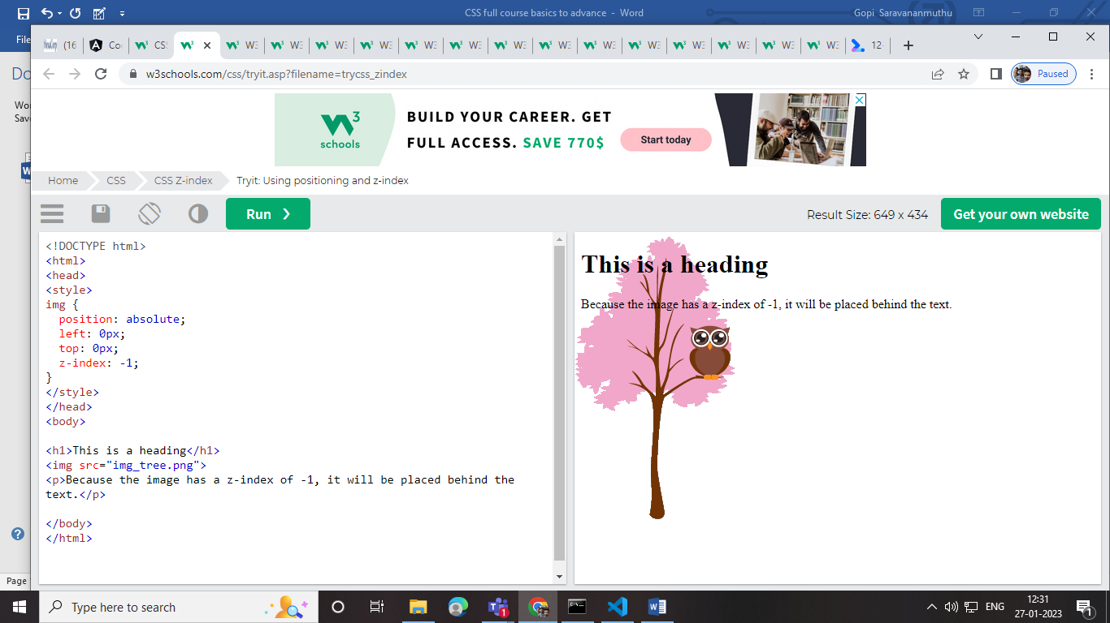

z-index 1 potta screenla contentukku munnadi vanthu nickum

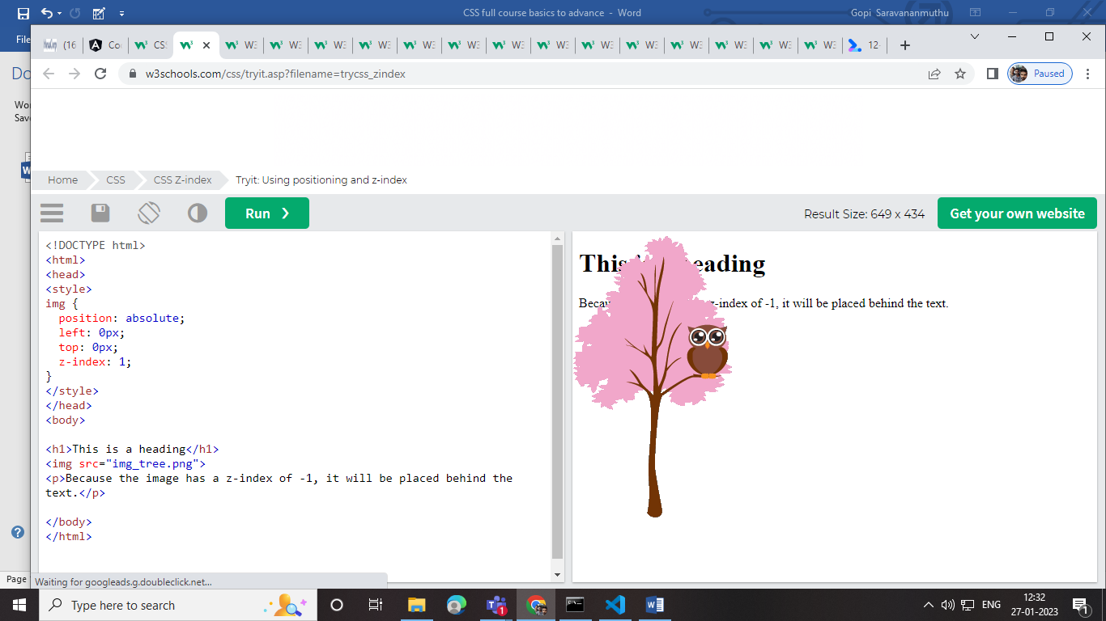

potta onnukku kueela onn -1 ,-2 ,-3 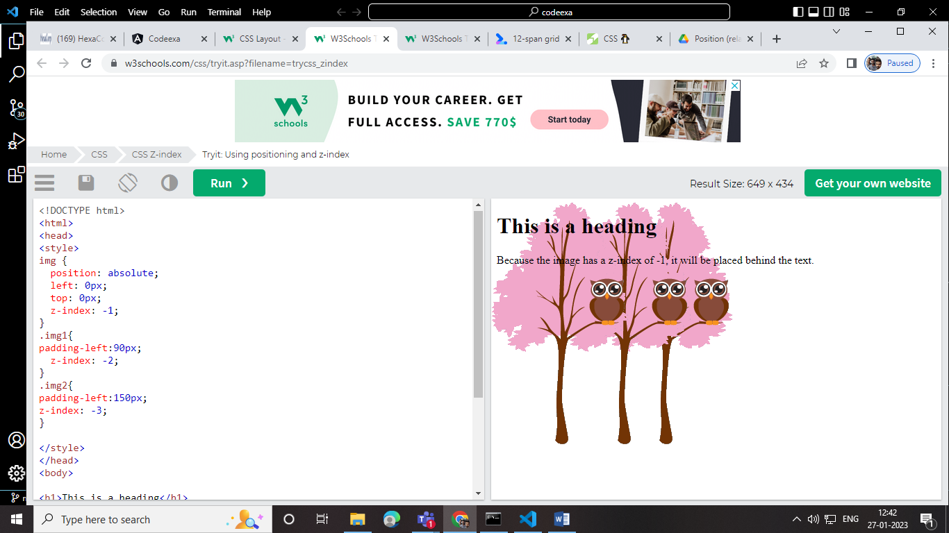

+1,+2,+3 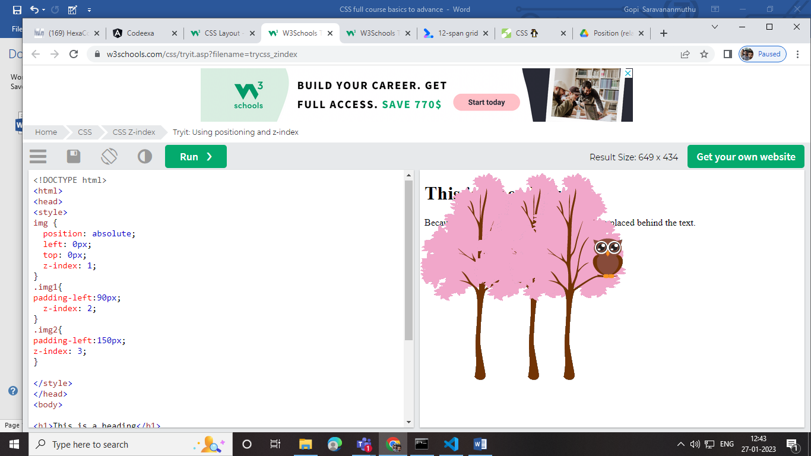

Float :

oru design document la img oru any content left, right ,bottom, endla place panniklam 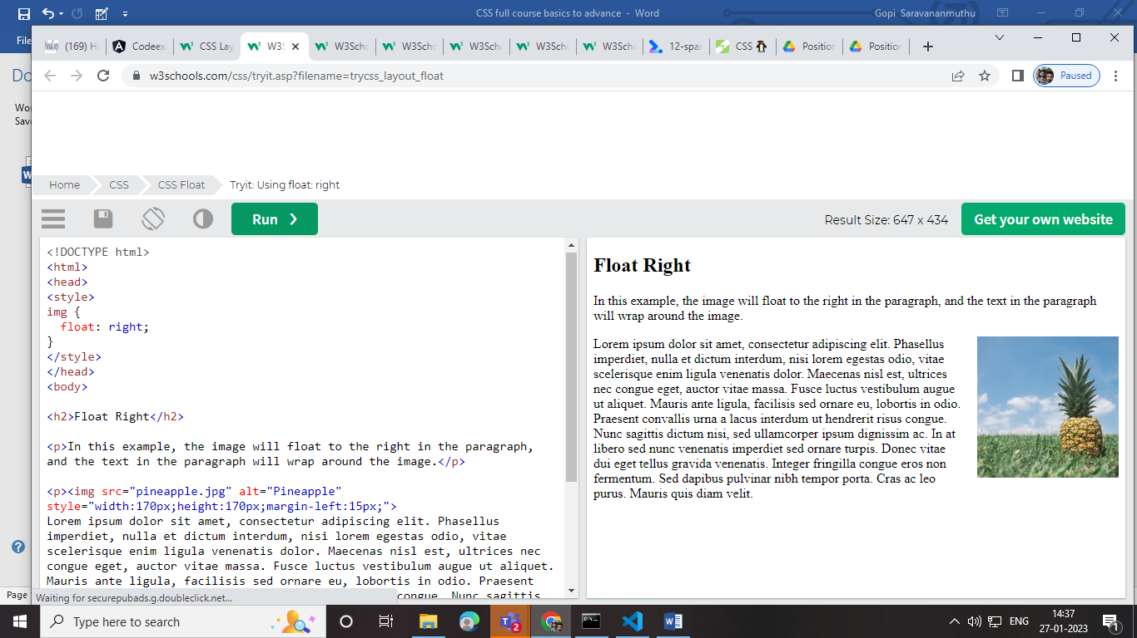

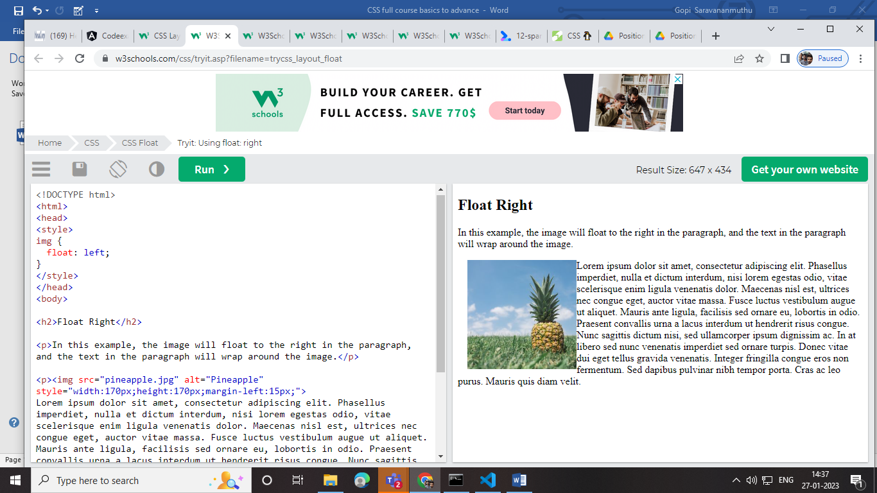

Combinatore:

>ithu vanthu parant to child like div > h1

Hover a:hover MUST come after a:link and a:visited in the CSS definition in order to be effective! a:active MUST come after a:hover in the CSS definition in order to be effective! Pseudo-class names are not case-sensitive.

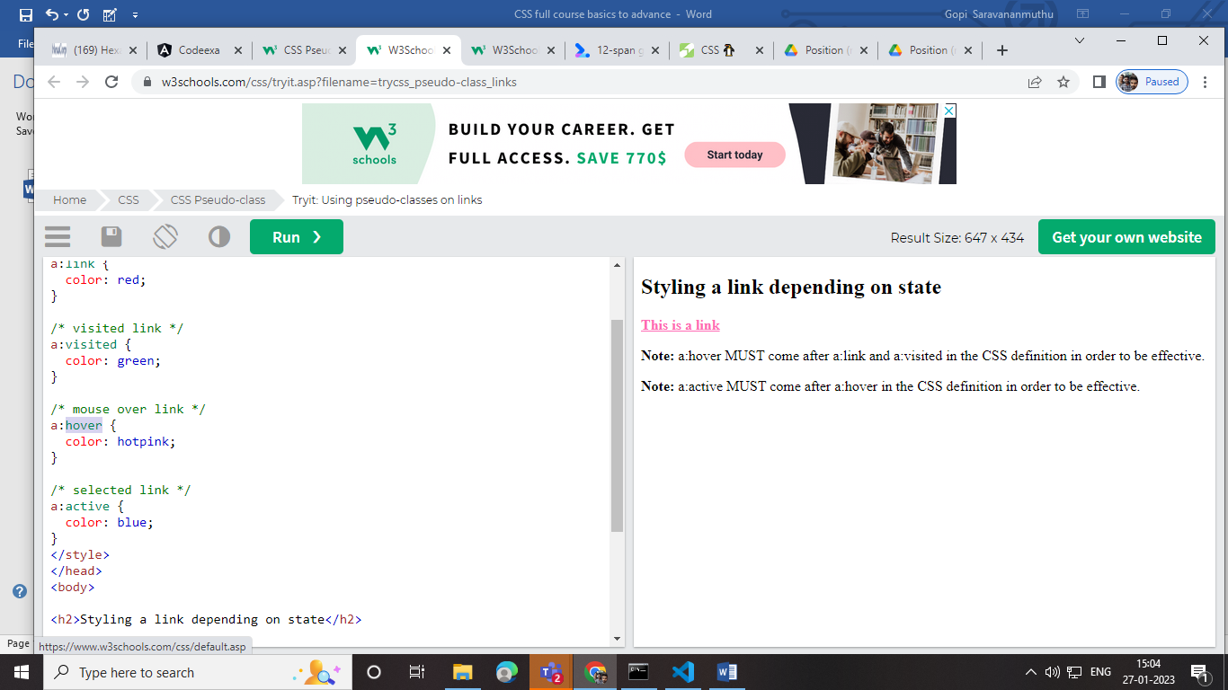

Counter-reset:

Nambala section koduthu number calculate aagikkum

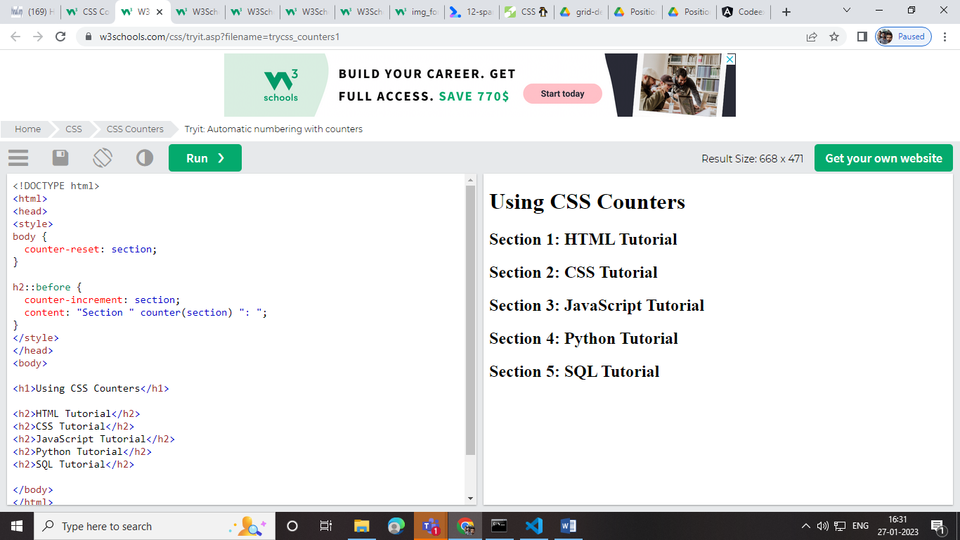

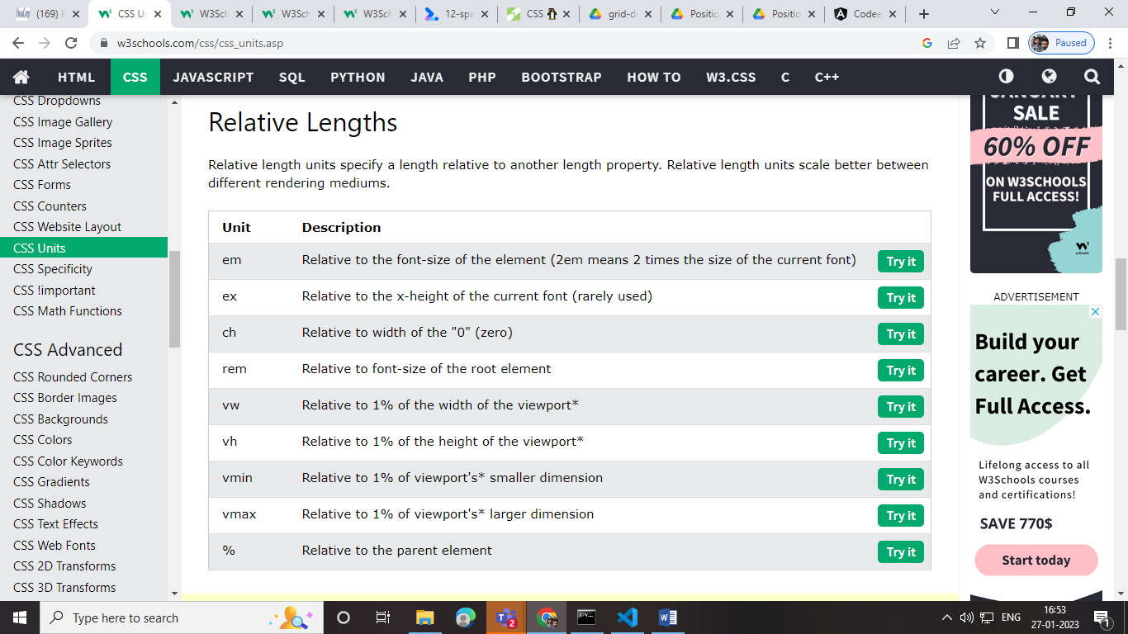

! important :

INTHA TAG ENGA PODUROMO ATHODA VALUE GLOBALA ACCESS AAGUM LIKE THIS 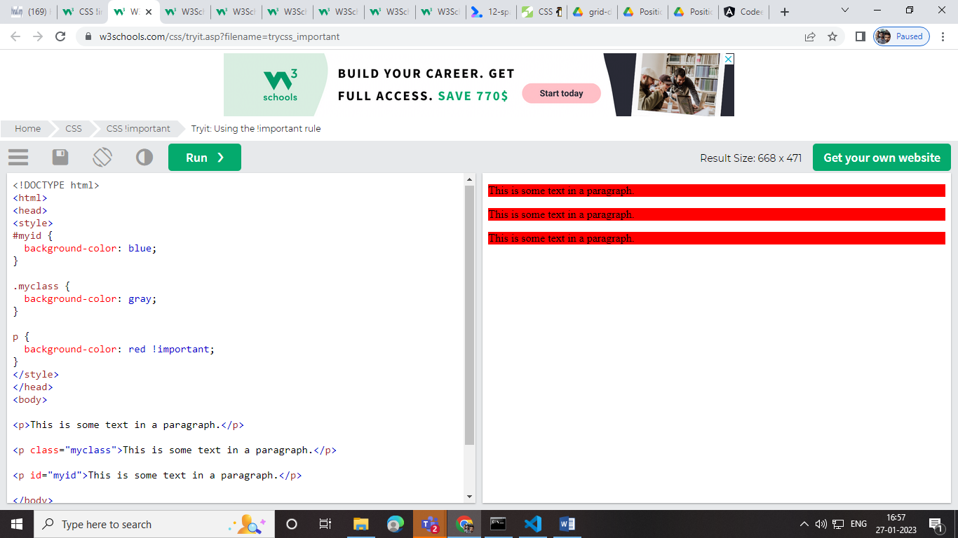

CSS- Advanced:

  border-radius: 25px;  
  background: url(paper.gif);  
  background-position: left top;  
  background-repeat: repeat;  
  padding: 20px;  
  width: 200px;  
  height: 150px;

## **CSS Border Images:**

With the CSS border-image property, you can set an image to be used as the border around an element.

border-image: url(border.png) 20 round;

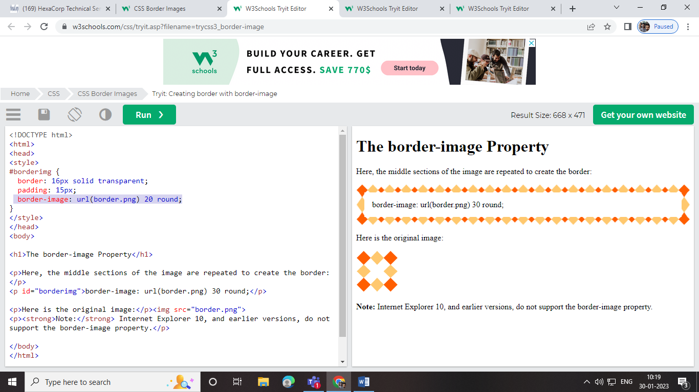

## **CSS Multiple Backgrounds:**

* background-size
* background-origin
* background-clip

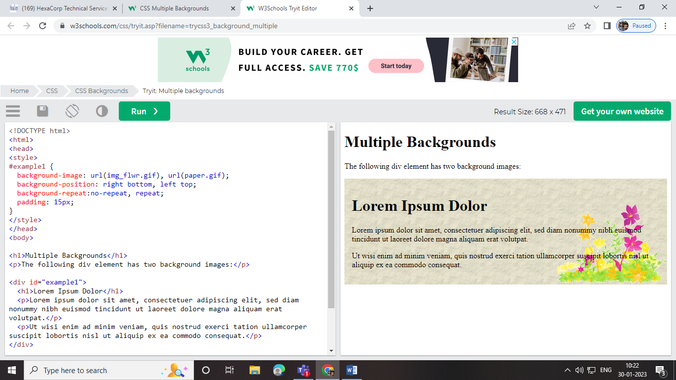

## The transparent Keyword:

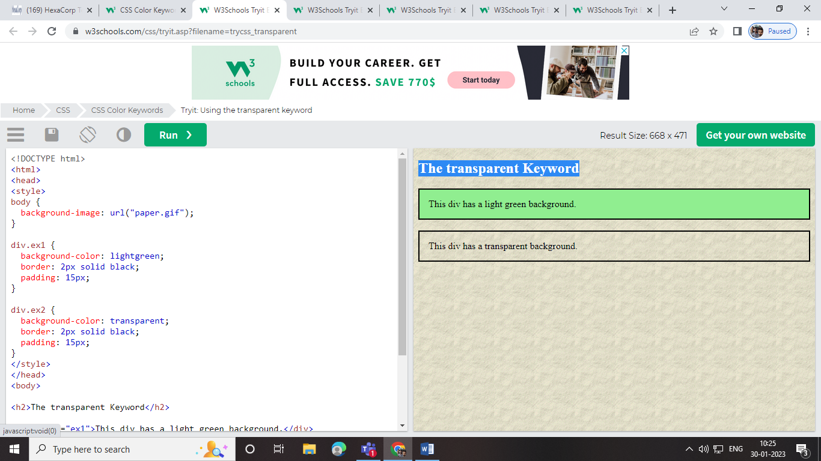

Linear gradient :

 background-image: repeating-linear-gradient(red, yellow 10%, green 20%);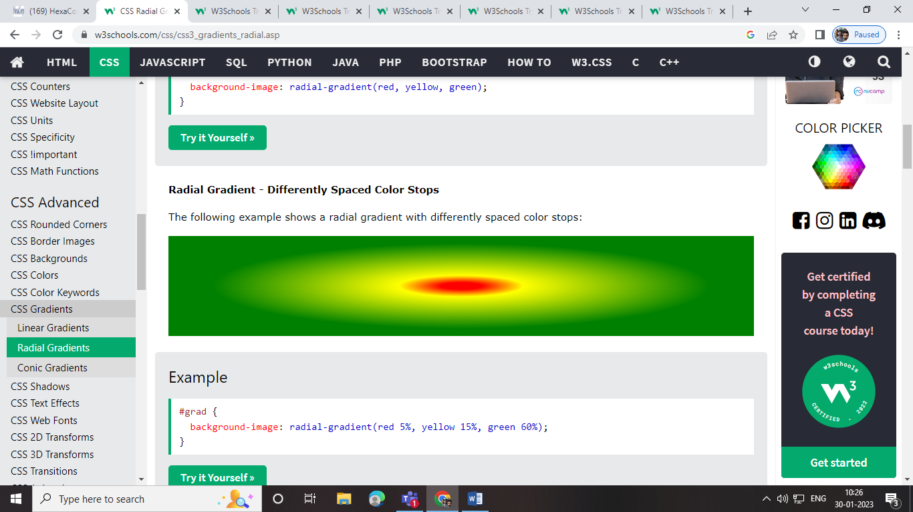

Shadows:

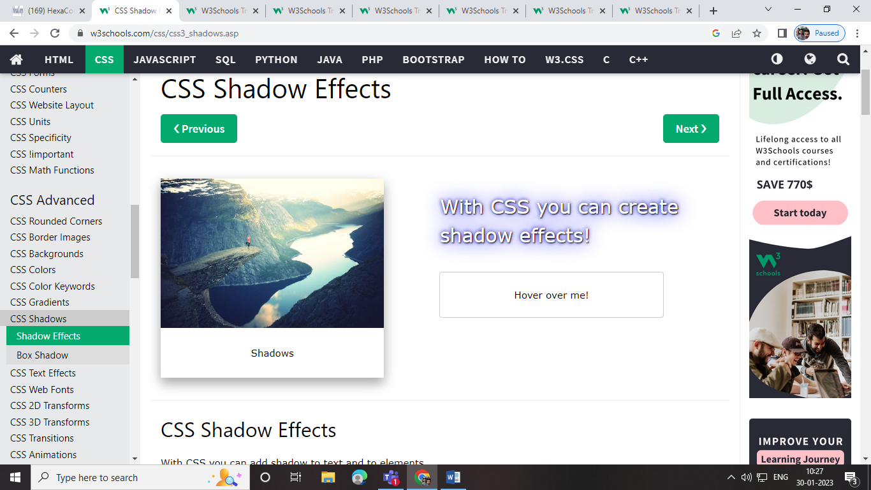

h1 {  
  color: white;  
  text-shadow: 2px 2px 4px #000000;  
}

h1 {  
  text-shadow: 2px 2px 5px red;  
}

h1 {  
  text-shadow: 2px 2px red;  
}

h1 {  
  text-shadow: 2px 2px;  
}

Box -shadow:

 box-shadow: 10px 10px 5px lightblue;

## **CSS Text Overflow, Word Wrap, Line Breaking Rules, and Writing Modes**

* text-overflow
* word-wrap
* word-break
* writing-mode

text-overflow: clip;

text-overflow: ellipsis;

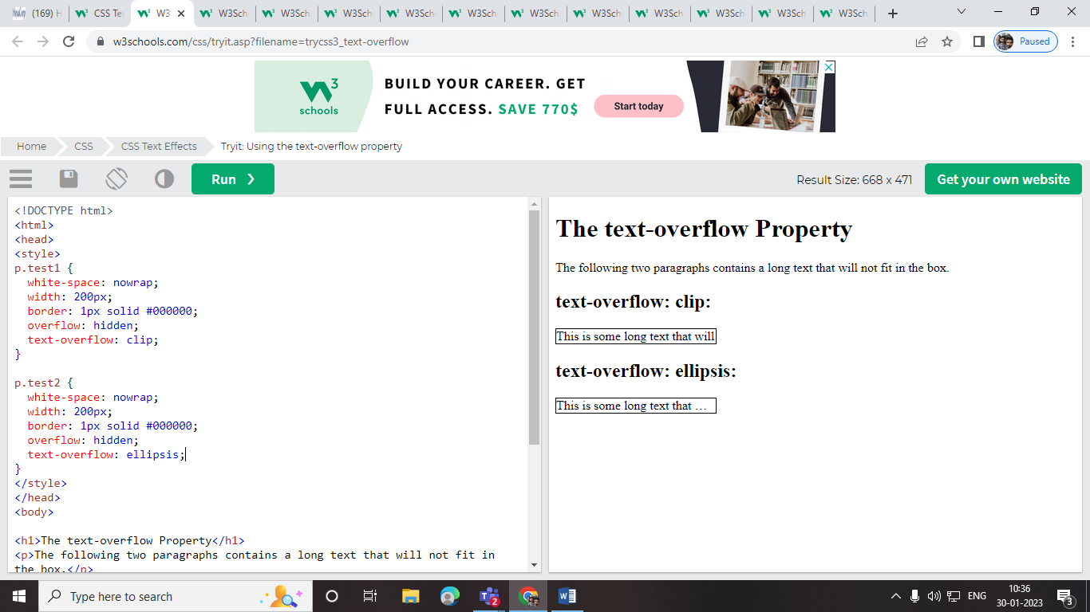

# The transition Property:

# To refer the css 3

# Image set panrathu

# .fill {object-fit: fill;} .contain {object-fit: contain;} .cover {object-fit: cover;} .scale-down {object-fit: scale-down;} .none {object-fit: none;}

# Example:

# img {   width: 200px;   height: 300px;   object-fit: scale-down; }

masking :

img kulla transpanrant img vakkirathu

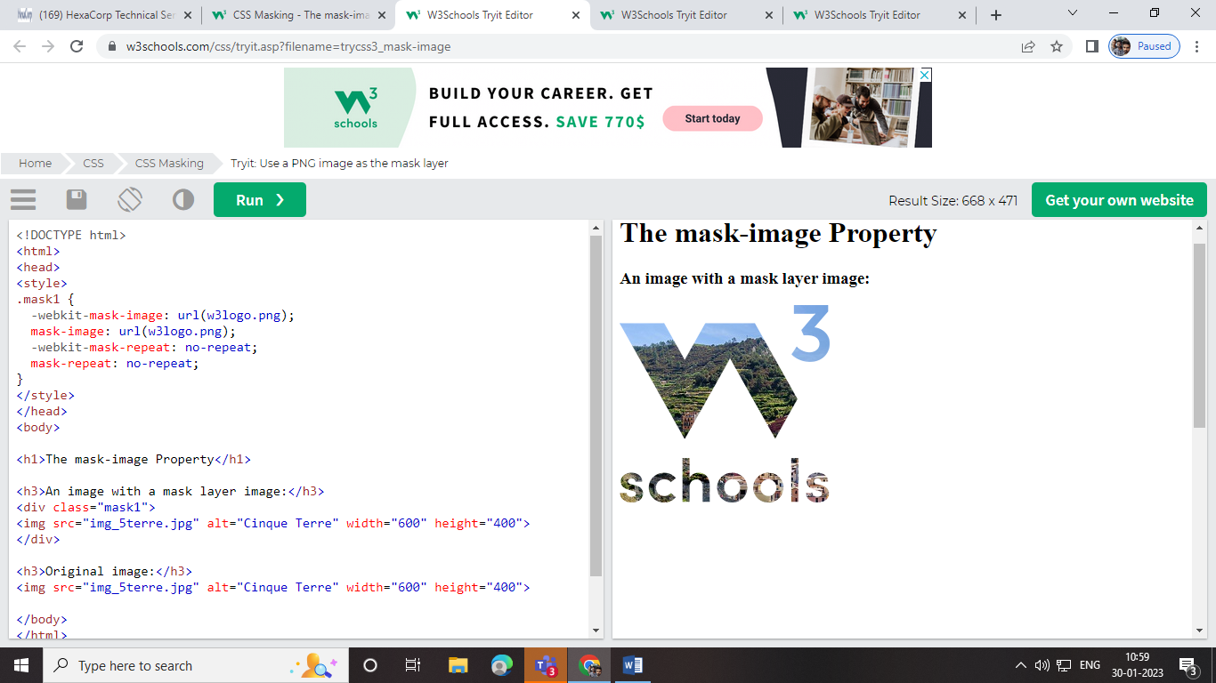

Easily understanding flow chart :

<https://coggle.it/diagram/YnE0DZ7qHbBk1JO_/t/css-penguin/bd77d153aef0f3e9c489e7d4f97dfee716fb4fd38e07513ac7818213c039ba77>

Display-flex

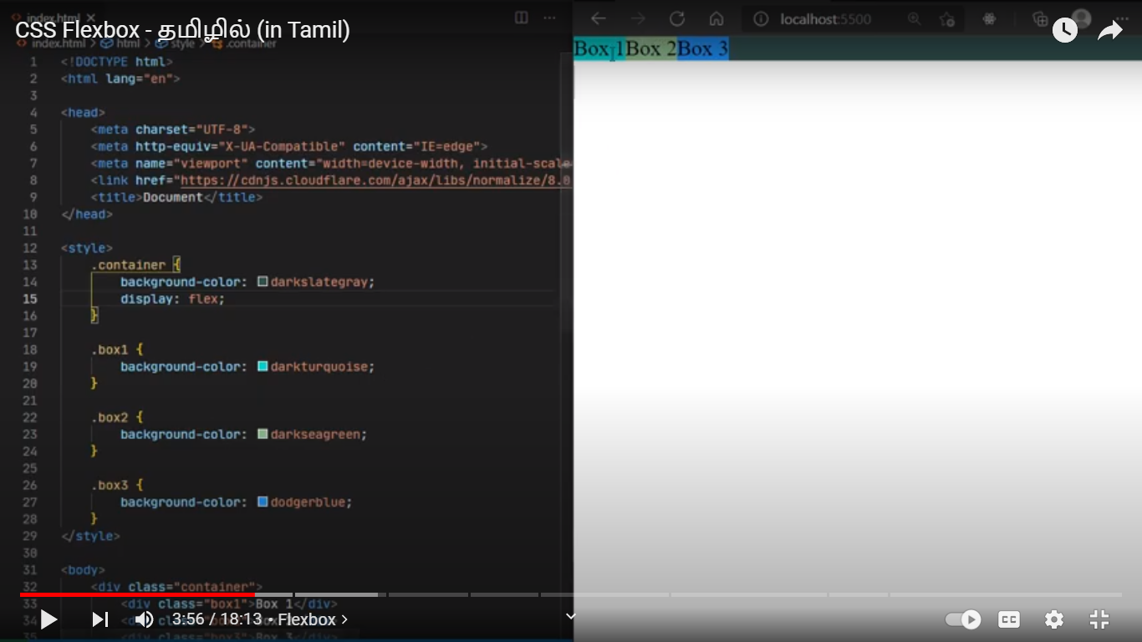

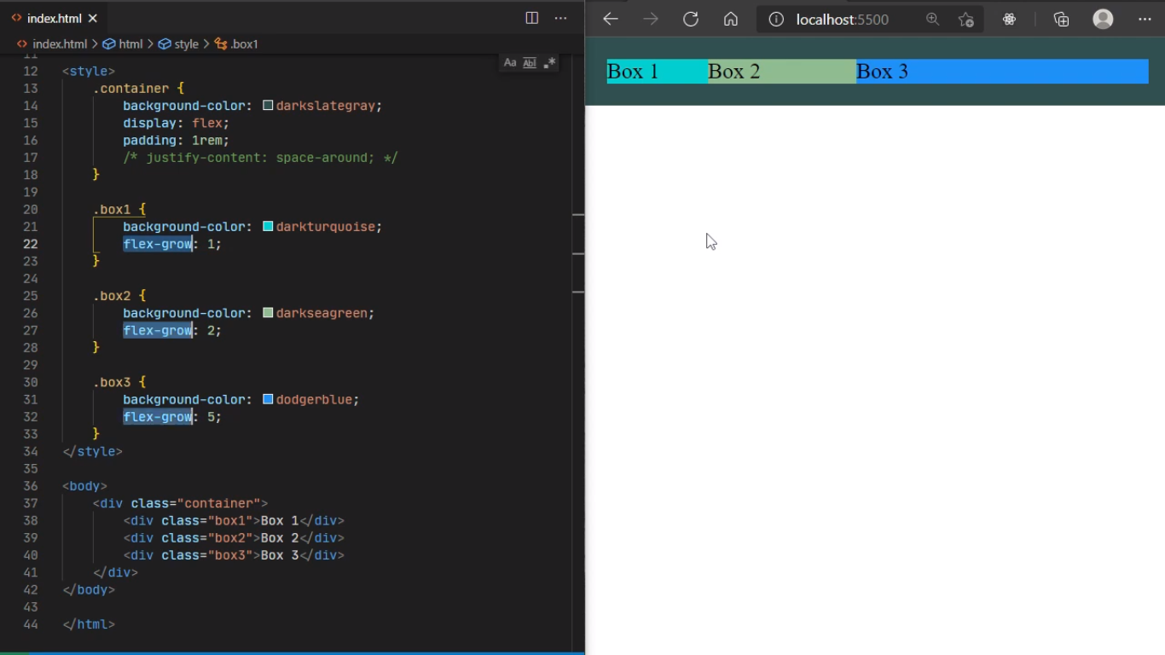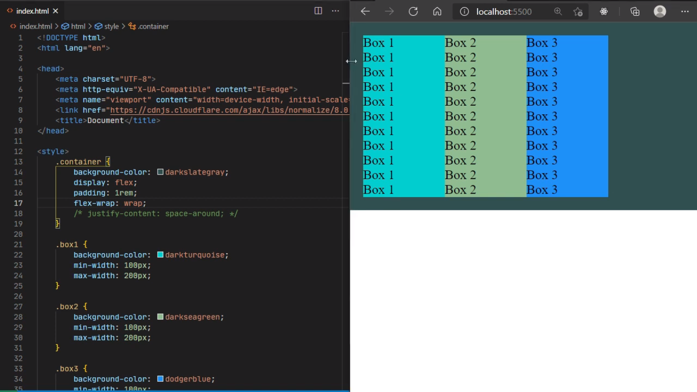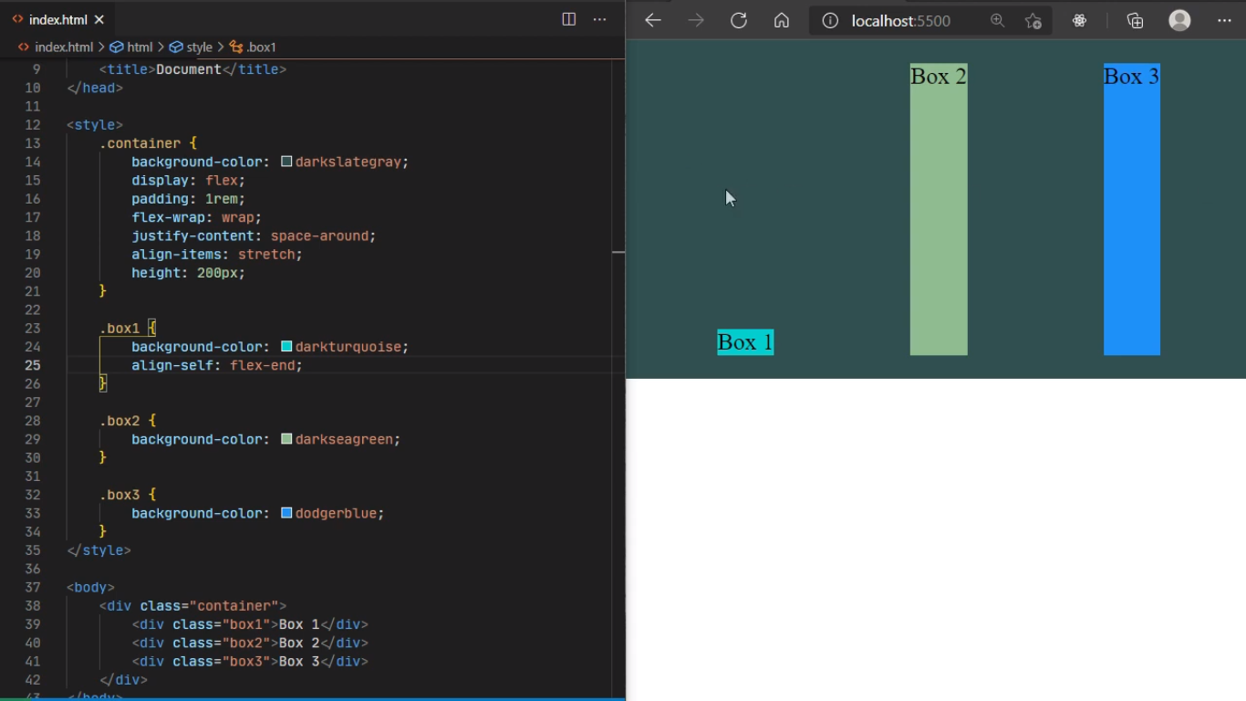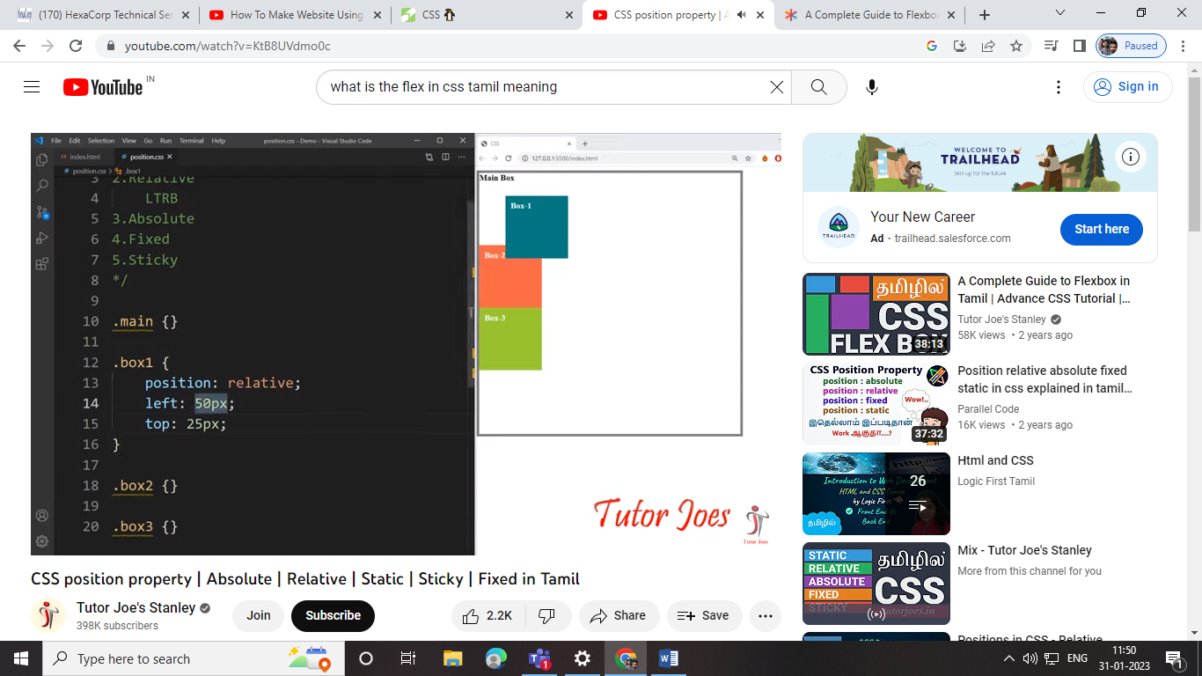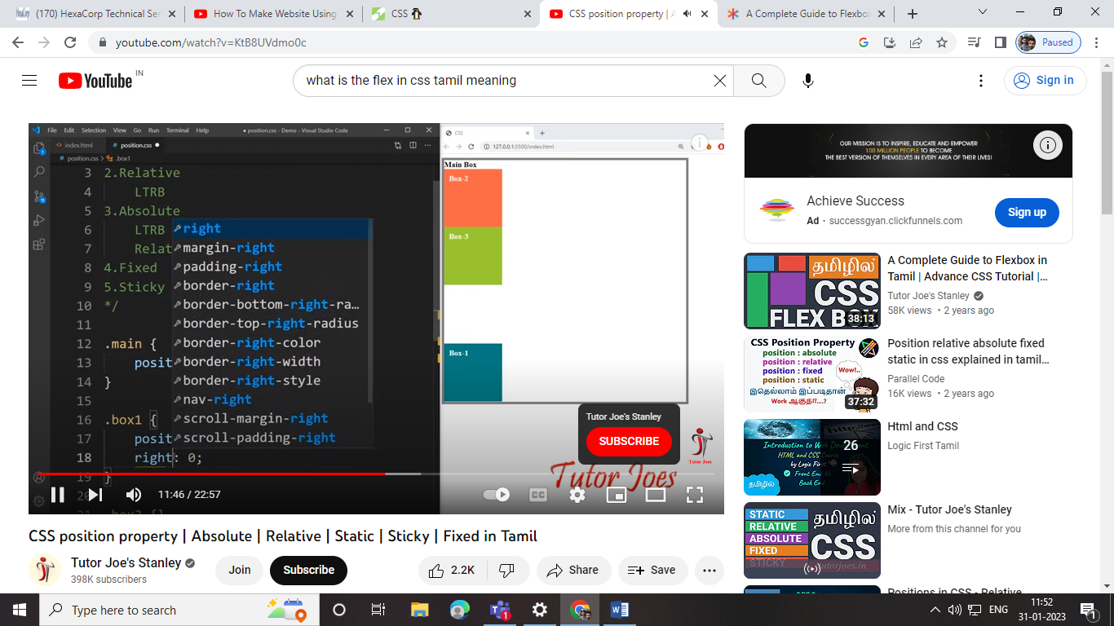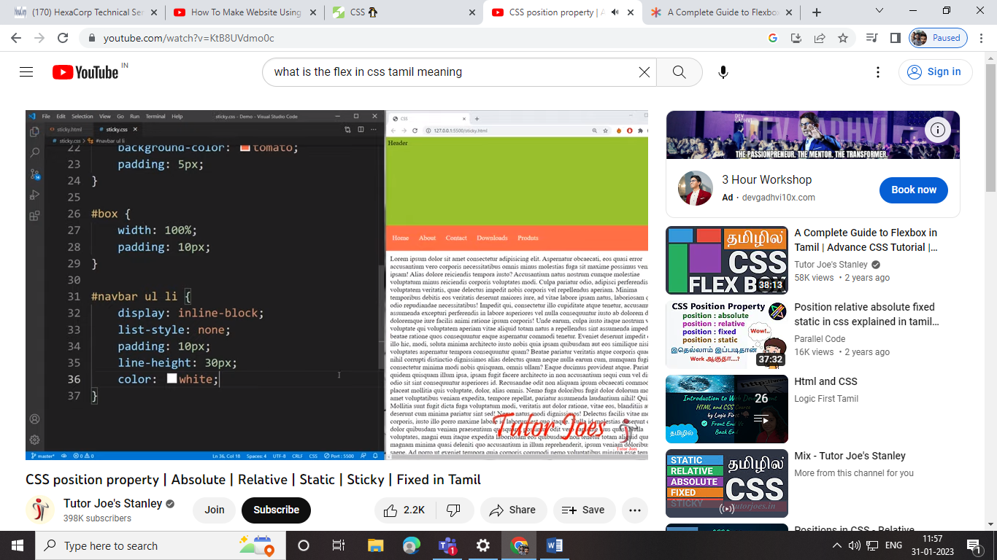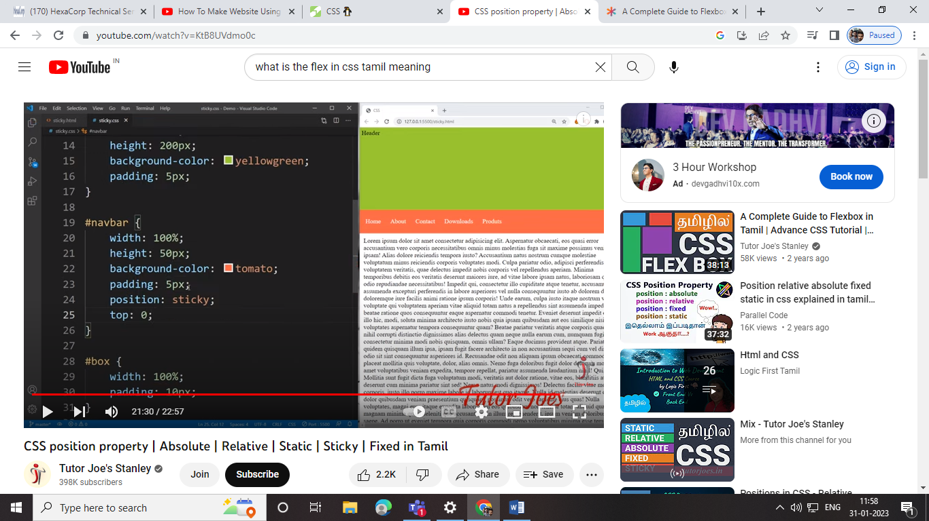

Bootstrap:

Bootstrap la ms -na oru line la end la podurathu

Mb-5 -> na irukkura contentukku keela space vidrathu

 @Output()

  Click_event_child : EventEmitter<any> = new EventEmitter();

<app-topbar flexLayout="column"></app-topbar>

<hr/>

<div flexLayout="row" fxFlex style="overflow: hidden;">

    <div fxFlex="5">

        <app-sidebar fxFlex></app-sidebar>

    </div>

    <div fxFlex="95">

        <router-outlet></router-outlet>

    </div>

</div>